ROYAL OAK INTERNATIONAL SCHOOL
SR. SEC. CBSE AFFILIATED
HOLIDAY HOME WORK (SESSION 2019-20)
Class – I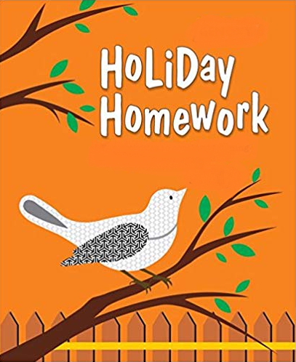

Please note the following:
- HHW of 5 marks will be added as a subject enrichment activity marks in Term I, hence submission of work post summer vacation is compulsory for all the students.
- Schedule for the Submission of HHW for all classes is as follows:
English : 3/07/2019
Hindi : 4/07/2019
Math : 5/07/2019
Evs : 8/07/2019
- Submission dates for Computer, Art & Craft will be in the 2nd week of July.

Wishing you all a very fruitful and enjoyable vacations. HAPPY HOLIDAY!

FOR THE PARENTS

Summer Vacations are here. A few vital suggestions are listed below to make the vacations more exciting and fruitful than ever before:
- Keep at least half an hour a day for sharing experiences with your child.
- Encourage your child to speak in English. Fix one hour in a day when you communicate with your child only in English.
- Tell your child different stories regularly and encourage him/her to describe what he/she would do in a similar situation. Here are few suggested titles which you can read with your child.
a. Lacey-the little mermaid fairy d. Giraffe can’t dance
b. I like myself (Story book) e. Dolphins at the day break
c. Panchatantra stories
- Let your child colour, draw, paint, Play, Dance etc.
- Restrict his/her television watching, confining it to interesting children’s program, cartoon films, discovery channel etc.
- To improve the formation of letter, make your child write a page every day.
- Develop self help skills: Let your child dress and feed on his/her own.
- Make him/her understand the importance of cleaning his/her room and putting away toys and belongings after use.
- Take your child out for picnics and to other places of his/her interest. Ask him/her to make a note of all the places he/she visits and things he/she sees so that he/she is able to discuss his/her experience in class after vacations.
Have a nice time!
PRINCIPAL

ENGLISH:
- Do 10 pages of cursive writing in a separate notebook.
- Paste the picture of your favourite ‘Fruit’ or ‘Cartoon’ and write few lines about it.(on A4 sheet)
- Paste the pictures of any five places you want to visit in India and also write their names. (on A4 sheet)
- Read any 5 stories from your story book “A Treasure of Tales”which you like.
- Do reading practice of Ch-1 and Ch-2 ( Book – Wow ) for the Reading Skill Test on 5th July.
- Revise the whole syllabus done in the class thoroughly during vacation and take plenty liquid diet.

HINDI:
- A- 4 lkbt “khV ij vk dh ek=k ds 20 “kCn fy[kksA
- A- 4 lkbt “khV ij b dh ek=k ds 20 “kCn fy[kksA
- ikSf’Vd Qyksa ds fp= A- 4 lkbt “khV ij yxkdj “khV dks ltkvksA (jksy u0 1 ls 14)
- ikSf’Vd lfCt;ksa ds fp= A- 4 lkbt “khV ij yxkdj “khV dks ltkvksA(jksYk Uk0 15 ls 28)
- iBu & ikBu ijh{kk (Reading Skill Test) ds fy, isTk Uk0 16 ls 33 rd vH;kl djks A
- iBu & ikBu ijh{kk (Reading Skill Test)- 12th July, 2019(Friday).

MATH:
- PROJECT: Find out the names of ten animals. Take cut-outs of their pictures. Paste them on cardboard. Write number name on each picture and prepare a mobile.
2. Make a separate notebook and
a) Write counting from 1 – 100.
b) Complete the given worksheet.

EVS:
1. Family album:-
- Make a collage by pasting pictures of your family members.
- Write a few lines about your family members.
- Mention your family members along with their name.
- Mention the type of family you live in.
(Do in A3 size sheet)
2. Make an attractive modal using cardboard or thermocol:-
1. First aid box (Roll no. 1 to 15)
2. Traffic light (Roll no. 16 to 30)
3.Learn ch-1,2 and 3 and do the given work sheet.

COMPUTER:
- Revise PA1 syllabus.
- Draw and color the picture of computer in computer notebook.
- Paste the following pictures according to your Roll No on A4 sheet
  - Roll No. 1-15 Parts of computer
  - Roll No. 16 onwards Places where computer is being used.
- Do the given worksheet.

ART & CRAFT:
1. Table Mat with paper weaving design and laminate it
2. Beads the flowers (Ref. page no. 36 in Art & Craft book)

